**Second Semester Project**

**Computing year 2  
Group 2B2**

Gavin Moloney  
Kamel Shaaban  
Andrzej Zero

**Astronomy Equipment Sales website**

**Project Plan and Requirements**

Contents

Goals of the project 1

Feasibility of the project 1

Requirements analysis 2

Iteration Goals 2

Iteration One 2

Iteration Two 2

Iteration Three 3

Class and Use Case diagrams 4

Class Diagram 4

Use case diagram 5

Use Case descriptions 6

# Goals of the project

The main goals of the project are to create an e-commerce website for the sale of astronomy equipment and encourage customer engagement by providing them with the platform to upload their images taken with the use of the equipment they bought and vote for their favourite images.

The key users are astronomy enthusiasts which includes amateur astronomers and fields related to astronomy such as the increasingly popular astrophotography. Astronomy equipment and accessories prices can vary greatly from low to high but the website will not focus on one individual category of user budget, it will aim to cater for low entry, mid level and high end equipment users.

The primary functionality of this website is the sales platform so this area will be the priority to have working correctly and without errors.

# Feasibility of the project

The project team has built up experience and competence using Django from studying the platform and working with it last semester so we believe that the project is feasible within the timeframe.

During the planning stage the team devoted a lot of time for research of manuals and guides that will assist them with coding of various components of the system.

The team has aimed to be ambitious in our goals for the project, for instance, none of the team has created the functionality to allow customers to upload images with ratings before so we have predicted that this could and most likely will present us with challenges to solve. If we are unable to solve any issues our contingency is to create a more basic version of what we have planned for this functionality or else to remove the additional functionality as a fully working website with less functionality is much more preferable to a half working website with more functions.

The team is confident in developing the core functionality of the website, the sales platform without many major issues as all members have experience with this from Django projects last semester.

# Requirements analysis

The main features of every e-commerce website are a front end to display products and a shop containing the products and payment processing. These are our priorities for the first iteration.

## Iteration Goals

### Iteration One

The priority functionality to be implemented is the core functionality of the website, adding products and allowing customers to create accounts.

* Basic website design
* Add, Update, Delete
* User accounts
* Category
* Product
* Cart
* Shop
* Order
* Voucher

Iteration one will also include thorough testing of the functionality and removing errors and bugs.

### Iteration Two

Additional functionality will be introduced.

* Newsletter
* Photo gallery
* Upload of user pictures
* Image voting system
* Picture of the month gallery
* Contact
* User tracking - last login
* Product search

Integrating new features without breaking any of existing functionality and removing any remaining issues and bugs from the previous iteration will be a priority. Tests of existing and new features will be carried out.

### Iteration Three

This iteration will focus on improving the project by enhancing it’s existing functionality such as adding further products to the database, improving UI and other minor details. Extensive testing on various browsers will be a priority at this stage.

# 

# 

# Class and Use Case diagrams

# 

## Class Diagram

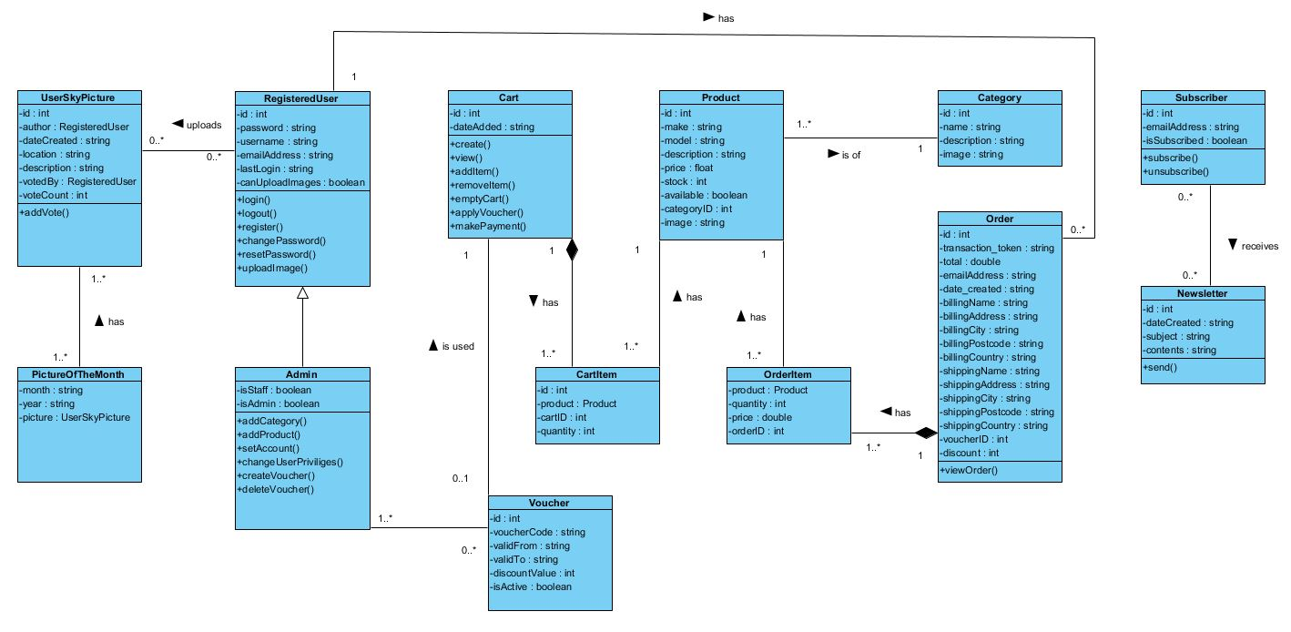

## Use case diagram

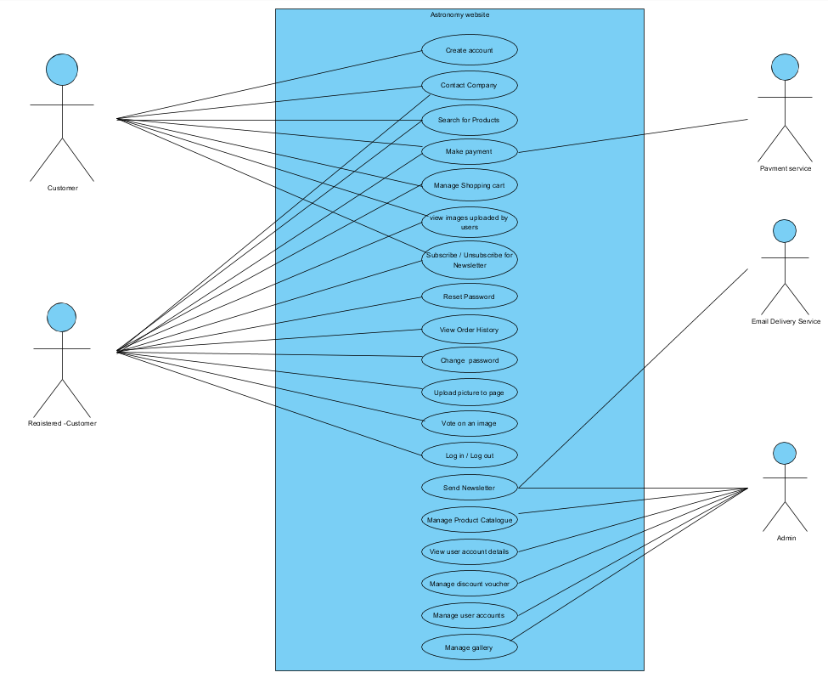

# 

# Use Case descriptions

|  |  |
| --- | --- |
| **Create Account (ID: 52)** | |
| **Use Case:** | Create Account |
| **Actor (s):** | Customer |
| **Goal:** | To create an account on the website |
| **Overview:** | Unregistered customers can become registered customers by creating an account. The customer selects the link on the site to sign up. The customer enters a username and a password and confirms the password. The customer presses the sign up button and the system redirects them to the login page. |
| **Pre-Condition:** | Customer has access to the website, valid email address. |
| **Post Condition:** | The customer becomes registered with a user account |
| **Successful Scenario:** | 1. Customer selects the link for sign up. 2. Customer enters a username. 3. Customer enters a password. 4. Customer confirms their password. 5. Customer presses the sign up button. 6. The system creates an account for the registered customer and redirects them to the login page. |
| **Alternative Scenario (s)** | **Step 6:**   * The customer has entered an invalid username. Customer is prompted to enter a valid username. * The customer has entered an invalid password. Customer is prompted to enter a valid password. * The customer incorrectly confirmed their password and is prompted but the system to re-enter their password correctly. |

|  |  |
| --- | --- |
| **Contact Company (ID: 43)** | |
| **Use Case:** | Contact Company |
| **Actor (s):** | Customer, Registered Customer. |
| **Goal:** | To contact the business through the contact form. |
| **Overview:** | Customers and unregistered customers can contact the company through email by filling in a contact form on the contact page. |
| **Pre-Condition:** | User has navigated to contact page. |
| **Post Condition:** | Customer has sent an email which the company receives. |
| **Successful Scenario:** | 1. Customer navigates to the contact page on the website. 2. Customer enters their name, their email address and their message. 3. System accepts this contact form and emails it to the company. |
| **Alternative Scenario (s)** | **Step 3:**   * If the customer does not enter a name or a message they will receive an error and allowed the chance to re-enter them. * If the customer enters an invalid email address they will receive an error and allowed the chance to re-enter a valid email address. |

|  |  |
| --- | --- |
| **Search for Products (ID: 33)** | |
| **Use Case:** | Search for Products. |
| **Actor (s):** | Customer, Registered Customer. |
| **Goal:** | Search if the product is available on the website. |
| **Overview:** | The customer can search for a product name or category and be presented with search results. |
| **Pre-Condition:** | User navigated to the shop page. |
| **Post Condition:** | Search result list is displayed on the page. |
| **Successful Scenario:** | 1. Customer navigates to the shop page. 2. Customer enters product name or category. 3. The system displays all products matching search criteria. |
| **Alternative Scenario (s)** | **Step 1:** Shop page was not found on the server, user is informed about it via proper error message.  **Step 3:** User entered name or category that does not exist in database and is informed by it by a proper message. |

|  |  |
| --- | --- |
| **Make payment (ID: 37)** | |
| **Use Case:** | Make payment. |
| **Actor (s):** | Customer, Registered Customer, Transaction Processing Provider. |
| **Goal:** | Pay for product(s) |
| **Overview:** | Customer makes payment for items existing in their shopping cart, if they have one they can use a voucher with a discount code to receive a discount on their purchase. |
| **Pre-Condition:** | Customer navigated to their cart page, items are added to customer's shopping cart. |
| **Post Condition:** | Customer paid for the items that were in their shopping cart, items are removed from the shopping cart and saved in order history. |
| **Successful Scenario:** | 1. Customer navigates to the shopping cart to make payment for previously selected items. 2. Customer can see the order details, can input voucher code if they have one, and they can proceed with checkout. 3. Customer clicks pay button and is prompted to enter their name and shipping details. 4. Customer enters their name and shipping details. 5. Customer is prompted to enter their card details. 6. Customer enters their card details. 7. Payment is processed by Transaction Processing Provider. 8. Payment is successful. |
| **Alternative Scenario (s)** | **Step 4:** Customer didn't enter all the necessary shipping details and is prompted to re-enter them.  **Step 6:** Customer entered wrong card details and is prompted to re-enter them.  **Step 7:** Payment was rejected by Transaction Processing Provider, customer is informed about it and transaction is cancelled. |

|  |  |
| --- | --- |
| **Manage Shopping Cart ID: (36)** | |
| **Use Case:** | Manage shopping cart. |
| **Actor (s):** | Customer, Registered Customer. |
| **Goal:** | View contents of customer's shopping cart, add and/or remove items from shopping cart. |
| **Overview:** | Customers, after placing the items in the shopping cart can review the contents of the cart, change the quantity of items in their shopping cart or remove one or more or all items from their shopping cart. |
| **Pre-Condition:** | User adds items to the shopping cart. |
| **Post Condition:** | Shopping cart details displayed to the user. If changed by the customer, item quantity changed in the shopping cart or item has been removed from the customer shopping cart entirely. |
| **Successful Scenario:** | 1. Customer navigates to their shopping cart. 2. Items in cart are displayed. 3. User selects an item and increases or decreases the quantity of the product they want to purchase. 4. An item/items quantity has been changed in the customer's shopping cart. |
| **Alternative Scenario (s)** | **Step 4:** No items have been put in the shopping cart, information displayed to customer about the empty cart. |

|  |  |
| --- | --- |
| **View images uploaded by users (ID: 51)** | |
| **Use Case:** | View images uploaded by users. |
| **Actor (s):** | Customer, Registered Customer. |
| **Goal:** | View images uploaded by other users to the community pictures page. |
| **Overview:** | The customer can view a gallery of previously uploaded by registered customers pictures of the night sky. |
| **Pre-Condition:** | The Customer navigated to the community pictures page. |
| **Post Condition:** | Community gallery page is displayed to the customer. |
| **Successful Scenario:** | 1. Picture gallery is displayed to customer |
| **Alternative Scenario (s)** | **Step 1:** Gallery page was not found on the server, user is informed about it via proper error message |

|  |  |
| --- | --- |
| **Subscribe/Unsubscribe from Newsletter (ID: 46)** | |
| **Use Case:** | Subscribe/Unsubscribe from Newsletter |
| **Actor (s):** | Customer, Registered Customer. |
| **Goal:** | To subscribe or unsubscribe from the company newsletter email. |
| **Overview:** | Customers can subscribe or unsubscribe to receive a newsletter from the company by email. They select the newsletter sign up link on the navigation bar of the website and confirm their sign up or unsubscribe using a form on the page. The newsletter system then sends the customer an email to confirm that they have successfully subscribed. When they unsubscribe they are informed by a message on the screen. |
| **Pre-Condition:** | Customer has navigated to the sign-up page. |
| **Post Condition:** | Customer is signed up to receive newsletters or the customer is removed from the mailing list. |
| **Successful Scenario:** | 1. Customer goes to the newsletter sign up page. 2. Customer selects sign up/unsubscribe for newsletter in the form, presses send. 3. Webpage confirms they have sent the form. 4. Customer receives an email confirming they are subscribed to the newsletter. |
| **Alternative Scenario (s)** | **Step 4**: There is an error in the system and the customer does not receive a confirmation email. |

|  |  |
| --- | --- |
| **Reset password (ID: 44)** | |
| **Use Case:** | Reset password |
| **Actor (s):** | Registered Customer |
| **Goal:** | The customer can reset their password. |
| **Overview:** | Registered customer has lost their password and can request a new one by clicking on the ‘forget password’ button and receiving a link by email. The customer then clicks on the link to reset the password. |
| **Pre-Condition:** | The Customer registers on the website. |
| **Post Condition:** | The customer will reset the password by receiving a link by email. |
| **Successful Scenario:** | 1. Customer Clicks on Forgot password. 2. The system will ask the customer to enter his email. 3. Customer enters their email. 4. The system will send a link to customer email. 5. The customer clicks links to enter his new password. 6. System saves the new password. |
| **Alternative Scenario (s)** | **Step 3:** System cannot find customer email. Customer prompted to re-enter email address. |

|  |  |
| --- | --- |
| **View order history (ID: 38)** | |
| **Use Case:** | View order history |
| **Actor (s):** | Registered Customer |
| **Goal:** | View order history. |
| **Overview:** | Customer login to his account and clicks on the order history page to see a list of all their previous orders. |
| **Pre-Condition:** | The customer must be registered and logged in. |
| **Post Condition:** | Customer can see their order history page and all their previous orders. |
| **Successful Scenario:** | 1. Customer logs into their account. 2. Customer navigates to the order history page and a list of all their previous orders is displayed. |
| **Alternative Scenario (s)** | **Step 1:** Customer is not registered in the website.  **Step 2:** Customer did not order anything yet and list of orders is empty. |

|  |  |
| --- | --- |
| **Change password (ID: 39)** | |
| **Use Case:** | Change password |
| **Actor (s):** | Registered Customer |
| **Goal:** | To change password. |
| **Overview:** | Customer logs into their account and wants to change the password. By clicking on the ‘change password’ button they are redirected to the password change page, they enter the current password and the new password and enter the new password again to confirm. |
| **Pre-Condition:** | The customer must be registered and logged in. |
| **Post Condition:** | The customer has changed the password. |
| **Successful Scenario:** | 1. Customer login to his account. 2. Customer clicks the change password button. 3. Customer enters the current password. 4. Customer enters the new password. 5. Re-enter the new password to confirm. 6. Customer clicks save password button. |
| **Alternative Scenario (s)** | **Step 1:** Customer didn't log in to their account because of incorrect password, user prompted to re-type.  **Step 5:** New password and confirm password don't match, user prompted to re-type |

|  |  |
| --- | --- |
| **Upload picture to page (ID: 34)** | |
| **Use Case:** | Upload picture to page |
| **Actor (s):** | Registered Customer |
| **Goal:** | To upload picture of the night sky made by user to page gallery. |
| **Overview:** | Registered users can share the pictures they made with page users by uploading them to customers' images page. |
| **Pre-Condition:** | Customer is registered and logged in. |
| **Post Condition:** | Registered customer successfully uploaded their picture. |
| **Successful Scenario:** | 1. Registered customer navigates to users gallery page. 2. Customer clicks on the upload picture button. 3. Customer is redirected to the upload page. 4. Customer selects a picture from their machine to be uploaded to the page. 5. Customer adds a picture description. 6. Picture is uploaded to the page. 7. Customer is redirected to the review page. 8. Picture is displayed on the customers' images page. |
| **Alternative Scenario (s)** | **Step 7:** Picture is not displayed because of unsupported file type  **Step 7.1:** User can edit the picture details and upload the correct file |

|  |  |
| --- | --- |
| **Vote on an Image (ID: 35)** | |
| **Use Case:** | Vote on an Image |
| **Actor (s):** | Registered Customer |
| **Goal:** | To vote a rating out of 5 stars on customer images on the customer image page. |
| **Overview:** | Registered customers can vote on images uploaded by registered customers on the customer image gallery page. |
| **Pre-Condition:** | The registered customer is signed in. |
| **Post Condition:** | The registered customer has voted on an image. |
| **Successful Scenario:** | 1. Customer enters their sign in credentials into the website. 2. System verifies the customer. 3. Customer navigates to the customer photo page. 4. Customer selects image. 5. Customer selects rating for image. 6. System accepts ratings. |
| **Alternative Scenario (s)** | **Step 3:** Customer has not logged in and cannot navigate to customer photo page. |

|  |  |
| --- | --- |
| **Manage Product Catalogue (ID: 59)** | |
| **Use Case:** | Manage Product Catalogue |
| **Actor (s):** | Admin |
| **Goal:** | To add a new product or product category to the database. |
| **Overview:** | An administrator can sign into the system administration page and add a new product or new product category to the database. |
| **Pre-Condition:** | Admin has sign in credentials and the database exists. |
| **Post Condition:** | A new product or new product category has been added to the database. |
| **Successful Scenario:** | 1. Admin enters admin sign in credentials on the system administration page. 2. System verifies admin credentials. 3. Admin selects to add a new category/product. 4. Admin enters the name of the category/product and clicks save. 5. system confirms category/product has been added to the database. |
| **Alternative Scenario (s)** | **Step 4:** Category/product not added because it already exists |

|  |  |
| --- | --- |
| **Send Newsletter (ID: 55)** | |
| **Use Case:** | Send Newsletter |
| **Actor (s):** | Admin, Email Delivery Service |
| **Goal:** | Send newsletter to email addresses who subscribed to receive one. |
| **Overview:** | An administrator can write and send newsletters to customers who subscribed to receive them. |
| **Pre-Condition:** | Admin has sign in credentials and is logged into admin panel. |
| **Post Condition:** | Newsletter is created and sent to subscribed email addresses. |
| **Successful Scenario:** | 1. Admin enters admin sign in credentials on the system administration page. 2. System verifies admin credentials. 3. Admin selects to add a new newsletter. 4. Admin enters newsletter contents. 5. Admin sends newsletter to subscribed addresses. |
| **Alternative Scenario (s)** | **Step 5:** Communication error with the email delivery service, newsletter has not been sent |

|  |  |
| --- | --- |
| **View user account details (ID: 42)** | |
| **Use Case:** | View user account details |
| **Actor (s):** | Admin |
| **Goal:** | To view details of Registered Customer accounts. |
| **Overview:** | An administrator can sign into the system administration page and view a registered customer's account details in order to assist them if any problem arises. |
| **Pre-Condition:** | Admin has sign in credentials and is logged into the admin panel. |
| **Post Condition:** | List of registered accounts and their details is displayed to the admin. |
| **Successful Scenario:** | 1. Admin enters admin sign in credentials on the system administration page. 2. System verifies admin credentials. 3. Admin selects to add a new category. 4. Admin navigates to the customers page. 5. List of registered accounts and their details is displayed to the admin. |
| **Alternative Scenario (s)** | **Step 1:** Cannot sign in due to incorrect credentials. |

|  |  |
| --- | --- |
| **Manage discount voucher (ID: 57)** | |
| **Use Case:** | Manage discount voucher |
| **Actor (s):** | Admin |
| **Goal:** | To add a new voucher with a discount code that can be used for a discount on checkout, edit or remove existing voucher. |
| **Overview:** | An administrator can sign into the system administration page and add a new voucher to database edit or delete existing one. The voucher will be valid for a period of time and enable the Registered Customers to receive a discount on their purchase when used during checkout. |
| **Pre-Condition:** | Admin has sign in credentials and is logged into the administration page. |
| **Post Condition:** | A new voucher has been added to the database, edited or removed. |
| **Successful Scenario:** | 1. Admin enters admin sign in credentials on the system administration page. 2. System verifies admin credentials. 3. Admin selects to add a new voucher. 4. Admin enters the name, lifespan and discount percent of the new voucher and clicks save. 5. System confirms the voucher has been added to the database. |

|  |  |
| --- | --- |
| **Manage user accounts (ID: 61)** | |
| **Use Case:** | Manage user accounts |
| **Actor (s):** | Admin |
| **Goal:** | To manage user accounts |
| **Overview:** | An administrator can create, delete or edit user accounts. Admin can grant or revoke staff privileges to an account. Admin can also revoke the users privilege to upload a picture to the website if the user has previously uploaded offensive content. |
| **Pre-Condition:** | Admin has sign in credentials and is logged in to the admin panel. |
| **Post Condition:** | User account created or privileges changed or account is removed. |
| **Successful Scenario:** | 1. Admin enters admin sign in credentials on the system administration page. 2. system verifies admin credentials. 3. Admin selects user account to modify. 4. Admin modifies the user account. |

|  |  |
| --- | --- |
| **Manage gallery (ID: 60)** | |
| **Use Case:** | Manage gallery |
| **Actor (s):** | Admin |
| **Goal:** | Manage the photos uploaded by users. |
| **Overview:** | An administrator can sign into the system administration page to find and remove from the website any offensive or inappropriate or not related to page theme images uploaded by users. |
| **Pre-Condition:** | Admin has sign in credentials. |
| **Post Condition:** | Offensive or inappropriate or not related to page theme images are removed from the website. |
| **Successful Scenario:** | 1. Admin enters admin sign in credentials on the system administration page. 2. System verifies admin credentials. 3. Admin navigates to the gallery section in the admin panel. 4. Admin finds the image that needs to be removed and clicks delete. |

|  |  |
| --- | --- |
| **Log in/Log out (ID: 62)** | |
| **Use Case:** | Log in/Log out |
| **Actor (s):** | Registered Customer |
| **Goal:** | To log in or log out from the website. |
| **Overview:** | Registered Customers can log in or log out of their account on the website. The customer selects the link on the site to log in or log out. The customer enters a username to log in. The customer presses the login button and the system redirects them to the login page, or the customer presses the log out button to log out. |
| **Pre-Condition:** | Customer is a Registered Customer. |
| **Post Condition:** | Registered Customer successfully log in to their account or logged out of their account. |
| **Successful Scenario:** | 1. Registered Customer selects a link for log in and is redirected to log in page. 2. Registered Customer enters a username. 3. Registered Customer enters a password. 4. Registered Customer presses the log in button. 5. The system verifies the user and redirects them to home page. |
| **Alternative Scenarios:** | **Step 1:** The customer selects a link to log out from the page and is logged out.  **Step 5:** The customer has entered an invalid username. Customer is prompted to enter a valid username.  **Step 5.1:** The customer has entered an invalid password. Customer is prompted to enter a valid password. |